Answer 1

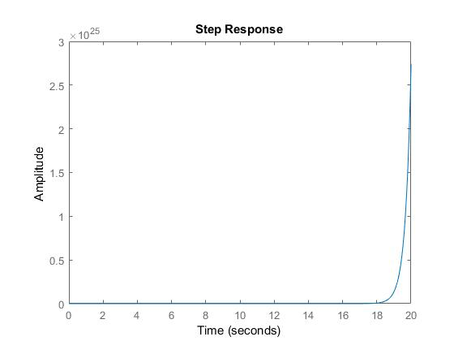

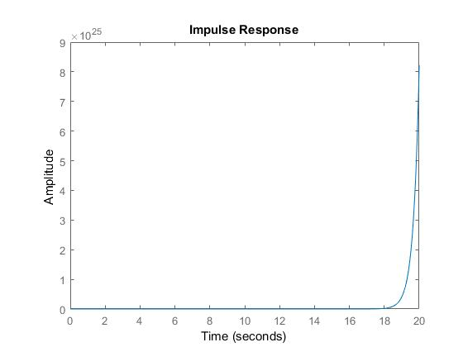

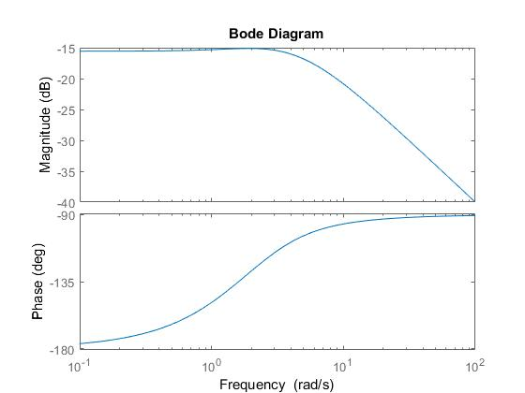

No, the system is BIBO stable. Because the magnitude increases and does not stabilize at any point.

Answer 2

Zero Pole Maps

|  |  |
| --- | --- |
| K | Plot |
| 1 |  |
| 2 |  |
| 3 |  |
| 4 |  |
| 5 |  |
| 6 |  |
| 7 |  |
| 8 |  |
| 9 |  |
| 10 |  |

Answer 3

The smallest value of K for which all the poles are in the left hand plane is 6.1

Answer 4

